**(1)10min**

**Q1:**

Identify actors and use cases for the system described above and show them on a UML Use Case Diagram. Give the Use case diagram of the above situation and the plant UML code

**A1:**

Actors:

Customer

Order System

Web Access

Phone Access

Use Cases:

Place Order

Check Order Status

Cancel Order

Request Catalog

Return Product (Phone Only)

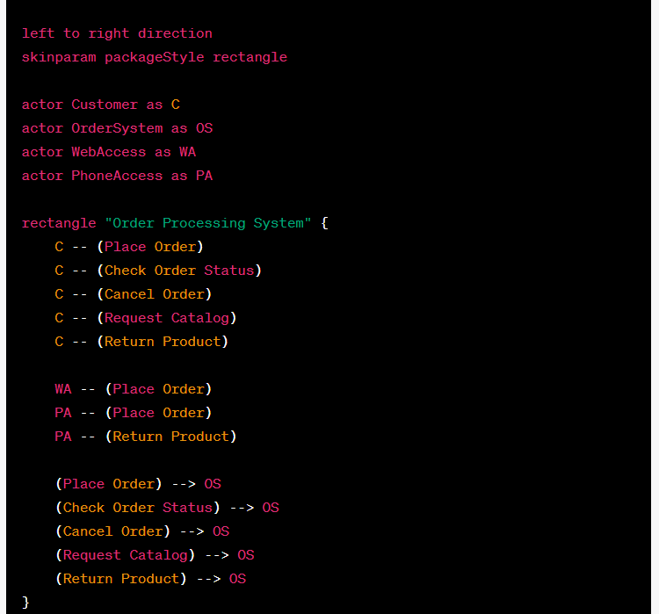

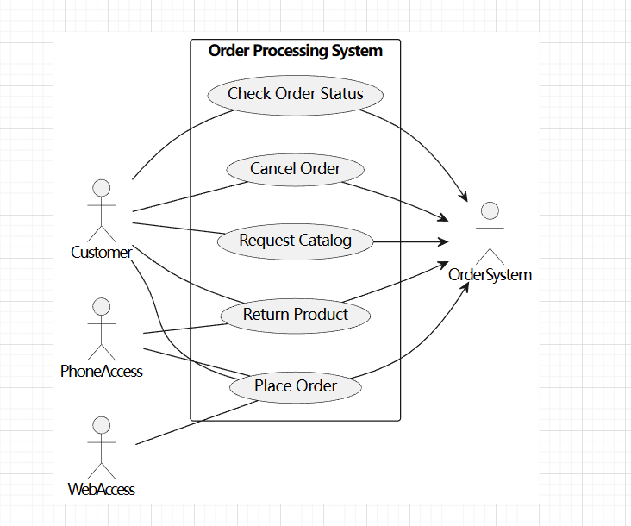

**Q2:** Update your Use case diagram and add descriptions about "golden users". Similarly, you need to provide the plant UML code.

**A2:**

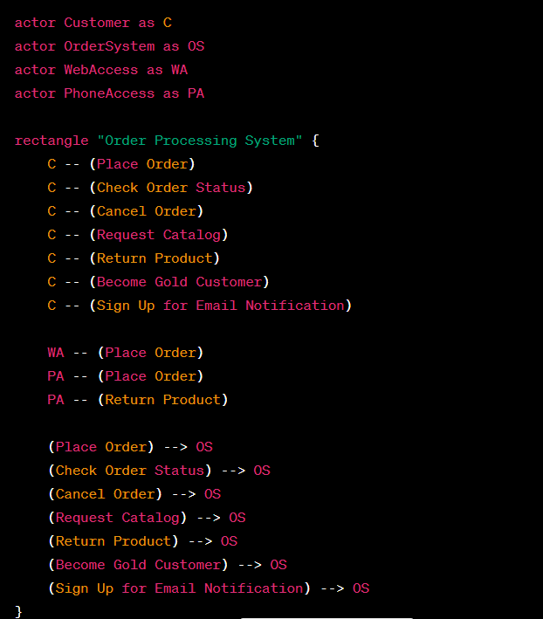

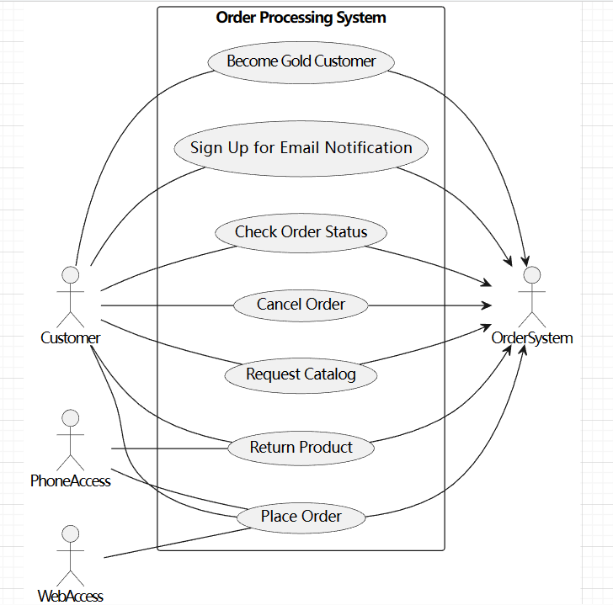

**(2) 12min**

**Q1:** Perform a quick application domain analysis to come up with an object model for the above system. Express your findings with a UML Class Diagram, making sure to identify any critical operations of classes. Give the plant UML code.

Consider the following use case scenario (for use case “place order”):

Ali is an existing customer of the order processing company described earlier, registered with their web site. Also assume that having browsed the printed catalogue he has, he already identified the two items (including their prices) he likes to buy from the company’s website using their product numbers (i.e. #2 and #9). First, he tries to buy one of product #2, but it is listed as unavailable in the inventory. Then, he adds two quantities of product #9, which turns out to be available, to his basket. He is then asked to confirm his registered shipping and billing addresses and credit card information from the customer database. He completes the order by clicking the Submit button. You may ignore processing of customer authentication.

**A1:**

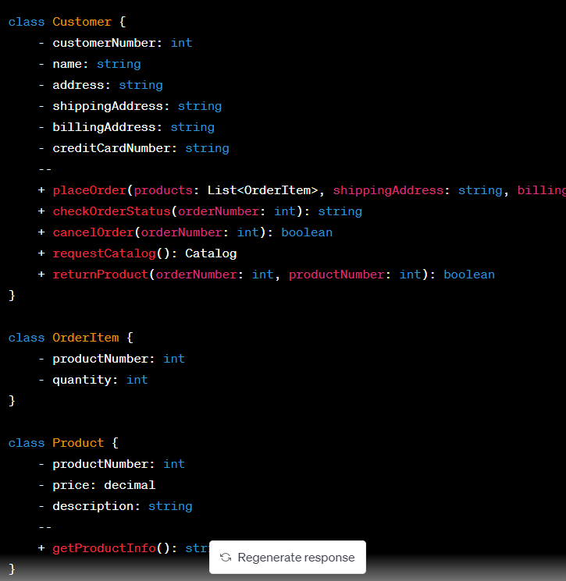

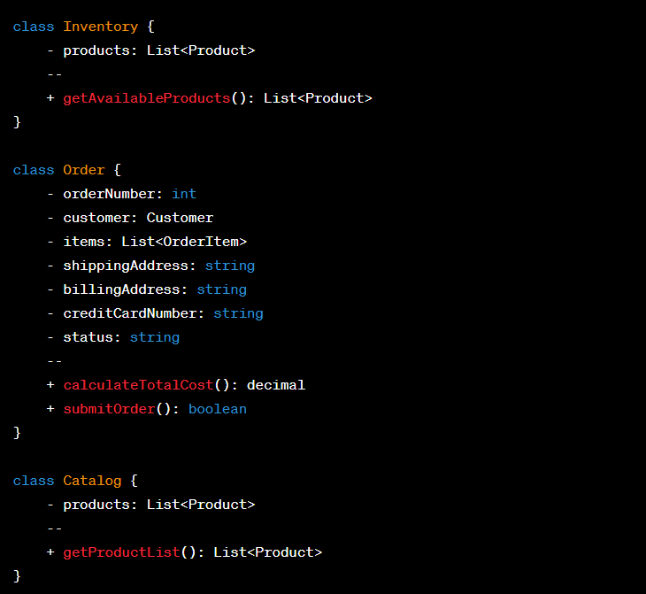

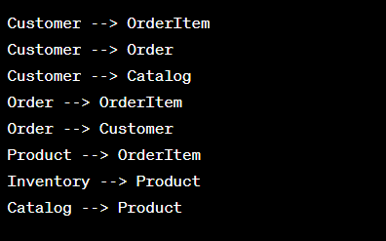

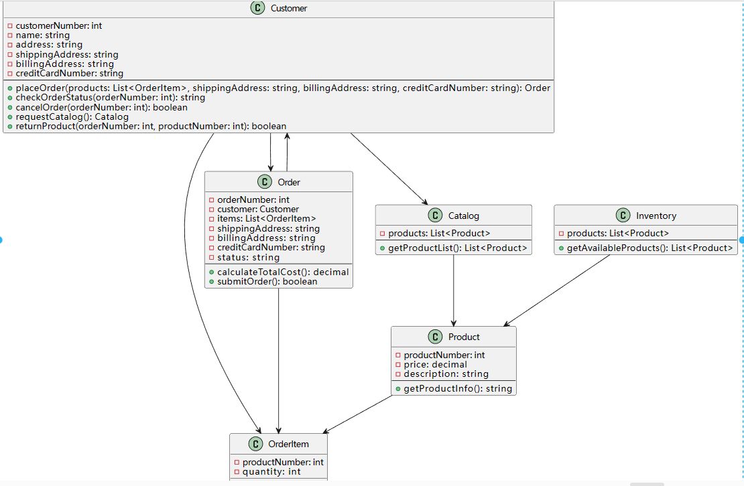

**(3)6min**

**A1:** Draw a sequence diagram for the scenario of the aforementioned Alibaba customer.

**Q1:**

